**COMPARISON OF OFF-CENTER AND END-FED WIRE ANTENNAS**

Paul Jursinic K9IRO

5643 Blue Jay Dr.

Kalamazoo, MI 49009

[pjursinic@outlook.com](mailto:pjursinic@outlook.com)

One reads in articles and hears in QSOs claims about how a radio operator’s new antenna is outstanding and provides for large numbers of long-distance contacts. Such anecdotal reports with no supportive data are really not helpful for a better understanding of differences in antennas.

One type of antenna, the end-fed wire antenna, has received many casual endorsements. The object of this study was to build an end-fed wire antenna and collect data to allow comparison of its performance to that of a more trusted design. In this study the more trusted design is an off center fed (OCF) wire antenna that is fed with ladder line. This OCF antenna has been used successfully for over a decade on all bands. This is a report of how an end fed wire compares to an OCF wire antenna.

Measurements that were used to compare the two antennas were made over 18 months on 80 and 40 m under a wide variety of band conditions. Additionally, calculations were made for the two types of antennas with a computer software antenna model. These measurements and calculations were compared in order to evaluate these two antennas.

The antennas that were built are shown in Fig. 1. These are wire antennas that are supported by trees. The antennas were intended to function on the 80 and 40 m bands. The end fed antenna is a compromise since the available trees did not allow the wire to be suspended in a straight line and it was partially folded back on itself.

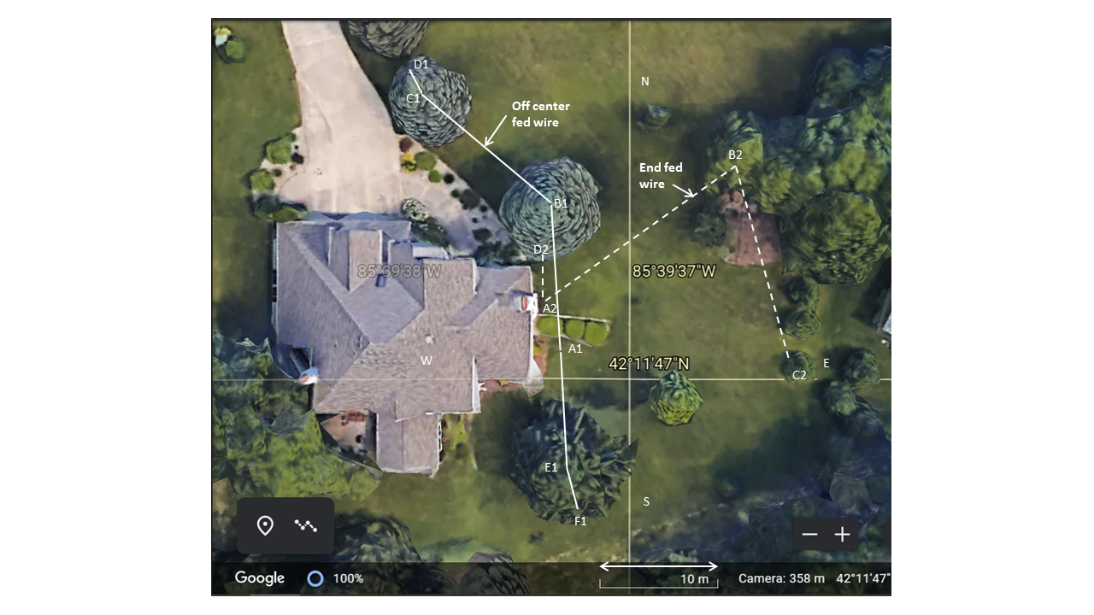

Figure 1. Two antennas mounted in the yard are overlaid on an image of the yard from Google Earth.

Antenna 1, A1-F1, is an OCF wire, shown with the solid lines in Fig. 1, is fed directly at point A1 with 65 feet of home built 600-ohm ladder line. Antenna 2, A2-D2, is an end fed wire, shown with dashed lines in Fig. 1, is fed with 15 feet of 300-ohm twin-line at point A2 through a toroid transformer. The short wire A2-D2 is a counterpoise that is 4 m long at a height of 2.41 m. This length, which is 5% of 80 m, has been reported [[1]] to be an effective length for a counterpoise. This 5% length recommendation will be tested in this project. The lengths and heights of the various wires and points of the antennas are given in Tables 1 and 2.

Table 1, OCF Wire. The center of the coordinate system is at east-west = 0, north-south = 0 , and height = 0 at the ground. Point A1 is located 15.24 m above the center of the coordinate system.

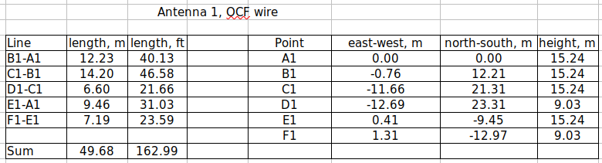

Table 2, End Fed Wire.

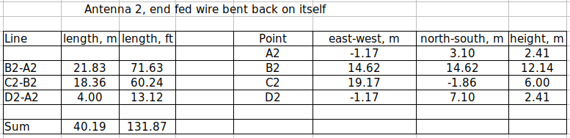

One challenge with an end fed wire is transferring power into the high impedance point that occurs at the end of the wire. In this project, a parallel wire transmission line, ladder line, through a step-up impedance transformer is used. This transformer also acts as a balun between the balanced input and the unbalanced output to the antenna wire. The transformer has 4 turns on the primary and 12 turns on the secondary, is wrapped on a FT-240-43 ferrite toroid core, and gives a 1:9 impedance transformation.

The feed circuits for the end fed and OCF antennas are shown in Fig. 2. Two identical Z-match impedance matching units were

built to match the impedance at the end of the feedline to the 50-ohm input/output impedance of the transceiver. The Z-match tuner is based on a multi-band tuning circuit that was described in QST [[2]] and in many articles online such as references [[3],[4],[5]]. The Z-match has a link coupled output, which is ideal for feeding an antenna with balanced transmission line. Balanced feed line has very low loss and is used to avoid large loss when standing waves occur on the feedline because of a poor impedance match at the antenna feed point [[6]]. For these antennas, a poor impedance match is expected between the transmission line and the antenna feed point and low loss feedline is important.

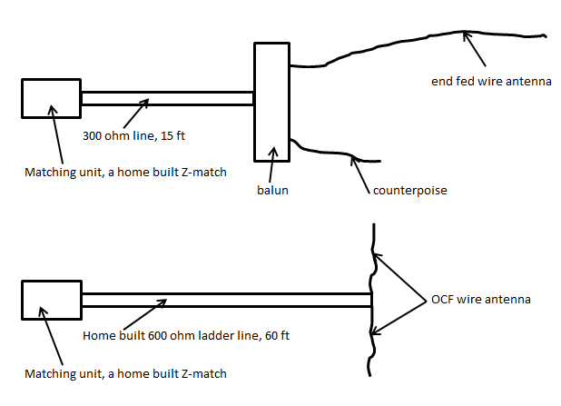

Figure 2. Antenna feed circuits.

The balanced feed line with the link coupled output has the additional advantage of little radiation if the RF current in each leg of the fed line is equal and out of phase by 180º[[7]]. A RF current-probe was built on a toroid [7] and used to measure the fed line current. The magnitude of the current was measured in each conductor of the feed line and then the magnitude of imbalance current was measured by placing both feed line conductors through the toroid. A single figure of merit of current balance was calculated as follows [7]:

$\text{balance}\left(\text{dB}\right)=\text{20}⋅\text{log}\left[\frac{I_{1}+I_{2}}{2⋅I_{\text{12}}}\right]$ Eqn. 1

where I1 is the RF current in wire 1, I2 is the RF current in wire 2, and I12 is the RF current measured simultaneously in both wires of the feedline. The limits for balance in Eqn. 1 are as follows. When I1 equals I2 and they are 180º out of phase, then I12 equals zero and the balance value is infinitely large; the current balance is perfect. When I1 and I2 are equal and in phase, I12 = I1 +I2, andthe balance value is -6 dB, which is the current balance value for maximally poor balance.

The antenna performance was tested by listening to random SSB stations on the 40 and 80 m bands. The station’s signal strength in dB above background noise was measured with a Flex-6300 transceiver while changing between antennas with a coax switch. Switching between antennas took less than a second so signal fading was not an issue. The Flex-6300 is an ideal tool since the measured signal strength is what occurs at the input of the receiver before any signal processing.

The transmitting station information was determined by entering the station call sign into the QRZ web site. Station details were determined, which include the bearing angle and distance between transmitting stations and the antenna.

The azimuthal pattern of antenna gain is dependent on the angle above the horizon of the transmission path. The elevation angle, α, for the path between the antenna and transmitting station was approximated with the following equation:

$α=arctan\left(\frac{2×n×h}{d}\right)$ Eqn. 2

where n is the number of skips, h is the virtual height of the ionosphere layer from which reflection or refraction occurs, and d is the distance between the antenna and the received station. Values for h for daytime propagation [[8]] are: 78 mi for the E layer for 3.6 MHz and 140 mi for the F layer for 7.1 MHz. Analysis of the stations that were measured on 40 and 80 m indicated that one and two skips were most common and the elevation angle was between 30 and 60º above the horizon. For simplicity in this analysis, a single elevation angle of the transmission path of 45º was used.

The antenna performance was modeled with EZNEC Pro2 v.7.0 software [[9]]. Losses in the feedline and Z-match were calculated with the TLW_Transmission Line for Windows software [[10]].

The following wire coordinates were used in EZNEC for the OCF and

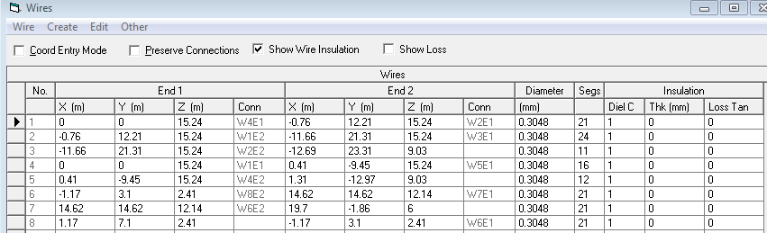end-fed antenna both being present. Note that both the connected and unconnected antennas are included in the model. This allows interaction of the two antennas to be included in the calculations.

For the OCF wire, a split source at segment one of wire 1 was used as the fed connection. For the end fed wire, a spit source was used between wires 6 and 8.

The ground was included as “real” and calculated with the high accuracy setting. Wire losses were included for copper wire.

**RESULTS**

A plot of the calculated gain of the two antennas on 80 m is shown in Fig. 3. The OCF wire has a typical pattern for a

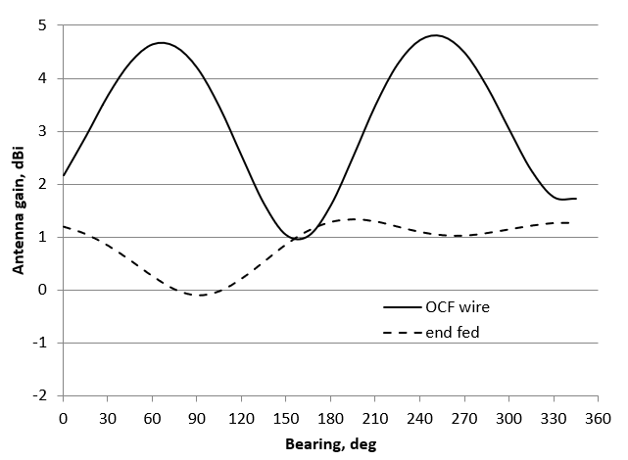

Figure 3. Antenna gain values for 3.6 MHz versus bearing angle calculated with EZNEC. A bearing angle of 0º is compass north.

dipole. The end fed wire is different than a dipole pattern because the wire folds back on itself as shown in Fig. 1.

The difference in the gain of these two antennas is shown in Fig. 4. EZNEC calculated differences are shown as a solid line

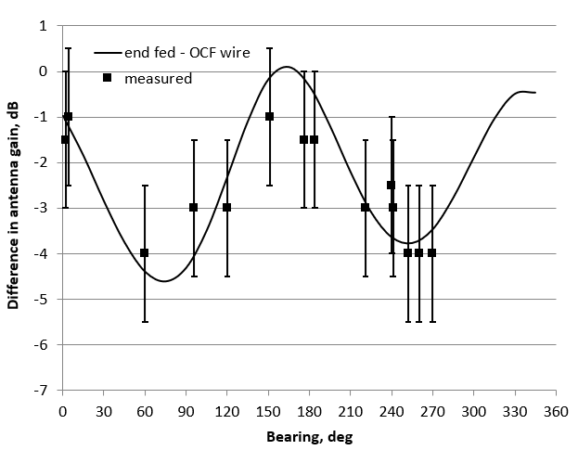

Fig.4. Calculated difference in antenna gain, end fed – OCF wire, for 3.6 MHz versus bearing angle are shown. Data from Flex radio measurements of random stations are also shown. The error bars indicate the range of difference between antennas for 5 measurements for a particular station. A bearing angle of 0º is compass north.

and measured differences between antennas are shown as square symbols. Within the measurement uncertainty the calculated and measured antenna gain differences agree. The end-fed wire, as deployed in Fig. 1, is inferior to the OCF wire by about -1 to – 4 dB or almost as great as 1 S unit at bearing 90 and 270º. At other bearings the difference is less than 3 dB. Keep in mind that one can barely perceive a 3 dB change in signal strength. So, the 3 dB drop in signal strength when switching from the OCF to end fed antenna is insignificant.

A plot of the gain of the two antennas on 40 m is shown in Fig. 5. The OCF wire has a typical pattern for a dipole fed with a

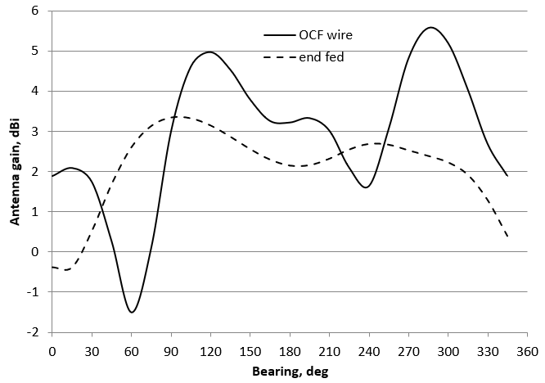

Fig.5. Antenna gain values for 7.1 MHz versus bearing angle calculated with EZNEC. A bearing angle of 0º is compass north.

RF voltage at half the wavelength, twice the frequency, of the antenna resonance. The end-fed wire is different because the wire folds back on itself as shown in Fig. 1 and the reverse in phase of the current that occurs in each half of the end fed wire fed on its second harmonic frequency.

The difference in the gain of these two antennas is shown in Fig. 6. EZNEC calculated differences are shown as a solid line

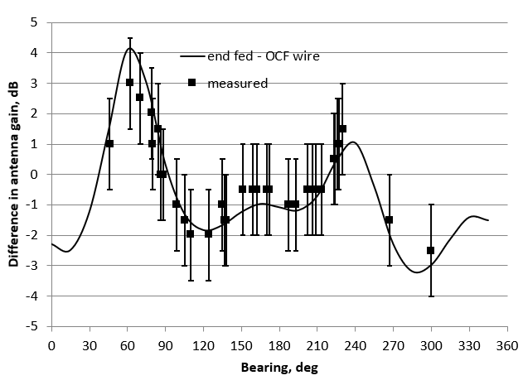

Fig.6. Difference in antenna gain, end fed – OCF wire, for 7.1 MHz versus bearing angle calculated with EZNEC. Data from Flex radio measurements of random stations is also shown. The error bars indicate the range of difference between antennas for 5 measurements for a particular station. A bearing angle of 0º is compass north.

and measured differences are shown as square symbols. Within the measurement uncertainty the calculated and measured antenna gain differences agree. The end fed wire, as deployed in Fig. 1, is equivalent to the OCF wire by about +3 to –3 dB. A change in signal strength when switching from the OCF to end fed antenna cannot be heard.

**FEED POINT IMPEDANCE VALUES**

These are various impedance values calculated with EZNEC. For the end fed antenna with the 1:9 transformer included, the antenna feed point impedance is at the primary of the transformer.

3.6 MHz

|  |  |  |
| --- | --- | --- |
|  | Antenna feed point impedance, ohms | End of feed line impedance, ohms |
| End fed no transformer | 1419 + j3057 | 94 –j811 |
| End fed with transformer | 103 +j259 | 325 +j573 |
| OCF | 229 +j832 | 154 –j594 |

7.1 MHz

|  |  |  |
| --- | --- | --- |
|  | Antenna feed point impedance, ohms | End of feed line impedance, ohms |
| End fed no transformer | 1060 + j308 | 151 –j270 |
| End fed with transformer | 96 +j38 | 259 +j333 |
| OCF | 404 +j970 | 105 +j351 |

Note, the high impedance of the end fed antenna is reduced to more reasonable values by using the 1:9 transformer.

**FEED LINE AND Z-MATCH LOSSES**

Whenever impedance matching is accomplished with a matching system, the power loss in the matching system is a concern. Many radio operators believe the use of a matching system must be avoided because it will present high loss. This is not necessarily true. The losses in feedlines and a matching system can be calculated with TLW software [10]. The Z-match is approximated with the L-network tuner in TLW. For the OCF antenna 600-ohm open wire line is used, 55 feet long, loss of -0.032 dB/100 ft at 3.6 MHz and -0.047 dB/100 ft at 7.1 MHz. For the end fed antenna 300-ohm twin line is used, 15 feet long, loss of -0.18 dB/100 ft at 3.6 MHz and -0.26 dB/100 ft at 7.1 MHz.

3.6 MHz

|  |  |  |  |  |
| --- | --- | --- | --- | --- |
|  | Line loss, dB | Tuner loss, dB | Total loss, dB | Total loss, % |
| End fed with transformer | -0.05 | -0.14 | -0.19 | -4.2 |
| OCF | -0.02 | -0.15 | -0.19 | -4.2 |

7.1 MHz

|  |  |  |  |  |
| --- | --- | --- | --- | --- |
|  | Line loss, dB | Tuner loss, dB | Total loss, dB | Total loss, % |
| End fed with transformer | -0.09 | -0.10 | -0.19 | -4.2 |
| OCF | -0.08 | -0.14 | -0.22 | -5.0 |

Twin line has 6-fold greater loss than 600-ohm open wire line. However, since the twin line is only 15 feet long the total loss is about the same as for 600-ohm line. As shown in the table, tuner losses are less than 0.15 dB. The combined power loss of the feedline and tuner is about 0.2 dB or 5%. In these calculations the loss in the toroid transformer was assumed to be negligible.

For the antenna arrangement presented here, these calculations show that the combined power loss in the feedline and impedance matching network is at a level of 5% and does not sustain the negative opinions of many radio operators about the use of impedance matching systems.

**CURRENT BALANCE**

Whenever parallel line is used for feeding an antenna many radio operators believe that the feedline will radiate. This is only the case if care is not taken to keep the current balanced in the feedline. In this work care is taken to to keep current balanced by using Z-match tuners, which have balanced, link, output coils.

The RF current was measured for both antennas fed through Z-match tuners. Measurements are also made using an L-network tuner [[11]], which is inherently unbalanced, and gives comparison values for an unbalanced system.

Balance, figure of merit, Eqn. 1

|  |  |  |  |
| --- | --- | --- | --- |
| **Antenna** | **80 m Z-match** |  | **80 m L-network** |
| OCF | 22.9 dB |  | 7.0 dB |
| End fed | 23.3 dB |  | 12.0 dB |
|  |  |  |  |
| **Antenna** | **40 m Z-match** |  | **40 m L-network** |
| OCF | 28.9 dB |  | 19.3 dB |
| End fed | 28.3 dB |  | 22.9 dB |

From these data it is clear that with the Z-match tuner the OCF and end fed antennas have RF current with high balance, higher figure of merit values. As expected, the L-network, which is inherently unbalanced, does not balance the RF current as well, resulting in low figure of merit values. Unbalanced current is more of a problem on 80 m than 40 m.

For the antennas used in this work these measurements demonstrate that the common belief that open wire line will radiate is incorrect. At power levels used in my environment, 100 W or less, no feedline radiation problems are experienced.

**OPTIMAL LENGTH FOR THE COUNTERPOISE WIRE**

It was desired to test how signal strength changed with length of the counterpoise wire. Signal strength was measured by a station 104 miles away was measured while using the end fed wire, with

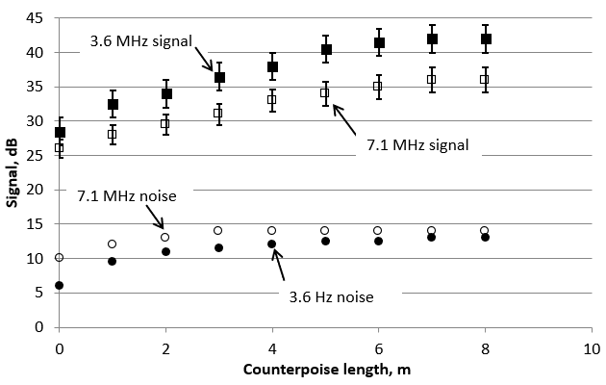

Fig.7. Antenna noise and received signal strength for different length counterpoise wires for 3.6 and 7.1 MHz. These are signal levels above the internal noise level of the receiver. The error bars indicate the range of difference for 5 measurements for a particular station.

different length of counterpoise wire attached. The internal

noise level of the receiver, with no antenna connected, is -127 dBm. Noise and signal levels when the end fed antenna is connected are shown in Fig. 7. The noise levels shown are environmental noise, which occurs when the antenna is connected and no transmitted signal is present. The signal levels are when the transmitted signal is present. It is clear in Fig. 7 that both signal and environmental noise begin to drop when the counterpoise length is less than 5 m for both 3.6 MHz and 7.1 MHz.

Changes in received transmitted signal above environmental noise are shown in Fig. 8. It is clear that the signal level drops

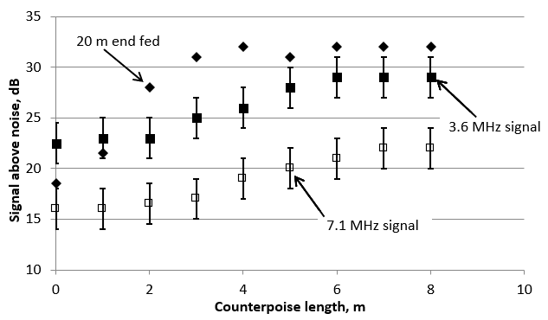

Fig.8. Antenna received signal strength above environmental noise for different length counterpoise wires for 3.6 and 7.1 MHz. Data are also shown for a 20 m long end fed wire. The error bars indicate the range of difference for 5 measurements for a particular station.

when the counterpoise length is less than 5 m for both 40 and 80 m. So, a counterpoise length of greater than or equal to 5 m should be used for this 40 m long end fed antenna. The 5 m length is 12.5% of the 40 m length of the end fed wire, or 6.3% of the 80 m wavelength of the lowest frequency used on this antenna. This is longer than the counterpoise length recommended previously [1], which is 5% of 80 m.

Based on the results of Figs. 7 and 8, one expects for a 20 m long end fed wire, which can be used for 7.1 MHz and higher, a counter poise at least 12.5% of 20 m or 2.5 m long will be adequate. The 40 m long end fed antenna in Fig. 1 was shortened to 20 m. Measurements shown in Fig. 8 for the 20 m long end-fed wire confirm that now a counterpoise greater than 2 m in length is adequate for receiving signals on the 20 m long end fed wire.

**CONCLUSIONS**

My initial prejudice against end-fed antennas has been shown to be wrong.  
  
From the data presented here, it is now appreciated that if you can efficiently get energy onto the wire, then the physics takes care of itself. The key elements for efficient energy transfer into the end fed wire are the following: 15 feet of twin line, 1:9 impedance transformer, and adequate counterpoise length. In retrospect, all of this should have been obvious but it was entertaining to build these antennas and make measurements that demonstrated how they compared.

The differences shown in Figs. 4 and 6 were based on received signals. These differences were also confirmed in many instances by engaging in QSOs with stations and switching between antennas when transmitting. The general trends were the same in receive and transmit modes.

1. The end fed wire, as deployed in Fig. 1, on 80m is not as good as the OCF wire by about 4 dB or 0.5 S units.
2. The end fed wire, as deployed in Fig. 1, on 40m is as good as the OCF wire; a difference when switching antennas cannot be heard.
3. Feeding the end fed wire with balanced line through a 1:9 impedance transformer is successful.
4. The counter poise wire is necessary and an optimal length is 12.5% of the longest wavelength to be used.
5. Calculations made with EZNEC agree, within measurement uncertainty, with on-air measurements that compare the OCF wire and the end fed wire antennas.
6. The end fed wire has the advantage of a short feedline that is 15 feet long, which is attached to the end of the antenna versus the middle.
7. Balanced current was measured in the parallel feedline fed through Z-match tuners with symmetric linked-coupled coils.
8. The feedline and tuner losses are low at a total loss of 4 to 5%.
9. Mounting the end fed wire so that it is in a straight line would improve its performance on 80 m. This is an experiment to run in the future.

1. Steve Yates, “The End Fed Half Wave Antenna”, <https://www.aa5tb.com/efha.html>
2. R.W. Johnson, “Multiband tuning circuits,” QST, July, 25-28 (1954).
3. Charlie Lofgren, “The Z-Match Tuner: An Update”, http://www.seboldt.net/k0jd/z-match.html
4. Phil Salas, “A Compact 100 W Z-Match Antenna Tuner”, QST, January, 2003, 28-30 (2003).
5. John Stewart, “The Z-Match Tuner”, <https://www.qsl.net/aa5kv/z-match.html>
6. ARRL, “Tramsmission Lines, Chapter 23”, The ARRL Antenna Book, 22 nd edition, The American Radio Relay League, Inc. Newington, CT, 2011.
7. Roy W. Lewallen, “Baluns: what they do and how they do it,”

   <https://www.google.com/url?sa=t&rct=j&q=&esrc=s&source=web&cd=&ved=2ahUKEwjuj-H2sNH9AhV1CTQIHV2kD4cQFnoECAcQAQ&url=https%3A%2F%2Fwww.eznec.com%2FAmateur%2FArticles%2FBaluns.pdf&usg=AOvVaw22FKIyzSZYSZHnC_F4wCh0>
8. ARRL, “Radio Wave Propagation, Chapter 4”, The ARRL Antenna Book, 22 nd edition, The American Radio Relay League, Inc. Newington, CT, 2011.
9. Roy Lewallen, “EZNEC Antenna Software by W7EL”, <https://www.eznec.com/>
10. [http://www.arrl.org/files/file/QST%20Binaries/June2014/TLW3.zip](http://www.arrl.org/files/file/QST Binaries/June2014/TLW3.zip)
11. Richard L. Measures, “A *Balanced* Balanced Antenna Tuner”, QST, February, 28-32 (1990).